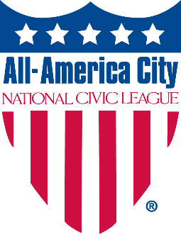
2025 All-America City Award
Letter of Intent to Apply Template
This is a sample for your use, but not the required language. Please email this letter by December 30, 2024, to aac@ncl.org to receive a $100 discount on your AAC application fee (full application fee is $250). Please note that a letter of intent is not required to apply.
Dear National Civic League staff:

I am writing on behalf of (the town, city, county, tribe, region), in the state of (name) to inform you of our intent to apply for the 2025 All-America City Award.

We believe our community is an excellent candidate for the All-America City Award because [provide a few sentences about how your community is addressing this year’s theme, as well as your culture of engaging residents and stakeholders in decision-making and collaborative problem-solving].

Our community contact person will be:

Name
Title or role it the community
Contact (email and phone)

We understand the application deadline is February 27, 2025. If named a finalist, we commit to bringing a community delegation to Denver, Colorado, for the second part of the application process: a live presentation to a jury at the 2025 All-America City Award Event, June 27-29, 2025.

Sincerely,

Name,
Title, Organization
Email address
Phone number

